JMJ
November 2024
HOT LUNCH MENU
SUN | MON | TUES | WED | THURS  Mrs. Theresa Kennedy  344-3151 or 335-2916 | FRI | SAT
 |  |  |  |   All Saints Day Nov1 | 1  Soft Pretzel Stick w/cheese sauce  Strawberry Yogurt  Celery Sticks  Corn  Fresh Apple | 2  
3 | 4  Breaded Chicken Patty on a Bun  Oven Fries  Mixed Vegetables  Diced Peaches | 5  Pepperoni Pizza  Romaine Lettuce Salad  Green Beans  Applesauce | 6  Beef Taco  Refried Beans  Mexi Corn  Strawberries | 7  Popcorn Chicken  Mashed Potatoes w/ckn gravy  Carrot Sticks  Grapes | 8  Grilled Cheese Sandwich  Tomato Soup  Celery Sticks  Mandarin Oranges | 9  
10 | 11  No School | 12  Cheeseburger on a Bun  Baked Beans  Sweet Potato Fries  Fresh Apple | 13  Chicken & Cheese Burrito  Pepper Strips  Corn  Mixed Fruit | 14  French Toast Sticks  Sausage Links  Hash Brown  Broccoli w/dip  Banana | 15  Cheese Pizza  Romaine Lettuce Salad  Cooked Carrots  Diced Peaches | 16  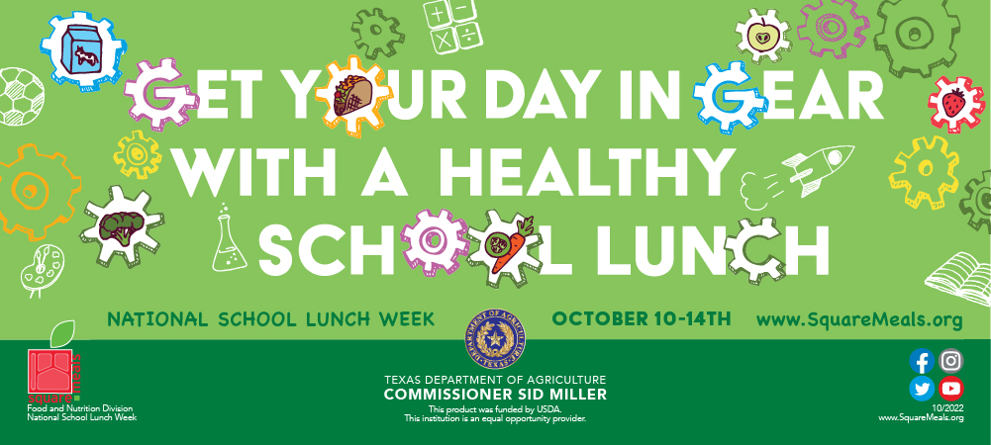
17 | 18  Beef Nachos  Pepper Strips  Corn  Applesauce | 19  Mini Corn Dogs  Sweet Potato Fries  Baked Beans  Diced Pears | 20  Ham & Turkey Sub  Chips  Celery Sticks  Peas  Mandarin Oranges | 21  Turkey  Mashed Potatoes w/country gravy  Green Beans  Garlic Toast  Cranberry Sauce  Chocolate Chip Cookie | 22  Fish Sandwich  Tater Tots  Broccoli w/dip  Fresh Apple | 23  
24 | 25  Cowboy Cavatini  Romaine Lettuce Salad  Cooked Carrots  Tropical Fruit | 26  Beef Hot Dog on a Bun  Tater Tots  Corn  Applesauce | 27  No School | 28 Happy Thanksgiving!  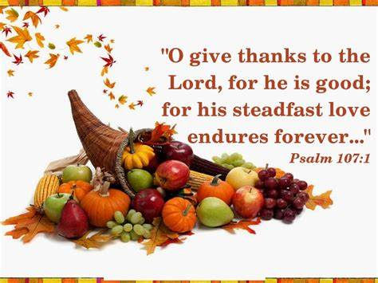 | 29  No School | 30
 | God Bless Our Families! |  |  | Menus are subject to change. | All meals are served with a  ½ pint of Skim Chocolate, or 1% White milk

