JMJ
February 2025
HOT LUNCH MENU
SUN | MON | TUES | WED | THURS  Mrs. Theresa Kennedy  344-3151 or 335-2916 | FRI | SAT
2  HEART  HEALTHY  MONTH!   | 3  Cheeseburger on a Bun  Tater Tots  Peas  Applesauce | 4  Pepperoni Pizza  Corn  Baby Carrots w/dip  Diced Pears | 5  Mini Corn Dogs  Sweet Potato Fries  Broccoli w/dip  Fruit Cocktail | 6  Beef Nachos  Corn  Cucumber Slices  Diced Peaches | 7  Grilled Cheese Sandwich  Tomato Soup  Celery Sticks  Mandarin Oranges | 8  
9  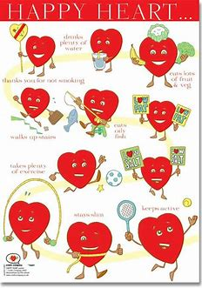 | 10  Ham & Turkey on a Bun  Steamed Broccoli  Baby Carrots w/dip  Strawberries | 11  Spaghetti with Meat Sauce  Garlic Toast  Green Beans  Pineapple Tidbits | 12  Breaded Chicken Patty on a Bun  Oven Fries  Baked Beans  Kiwi | 13  Taco in a Bag  Corn  Pepper Strips  Grapes | 14  !/2 Day  No Lunch  Happy Valentine’s Day! | 15  
 | 17  President’s Day  No School | 18  Beef Taco  Pepper Strips  Corn  Diced Peaches | 19  Pasta Bake  Garlic Toast  Green Beans  Carrot Sticks  Fresh Apple | 20  Popcorn Chicken  Mashed Potatoes w/ Ckn Gravy  Cucumber Slices  Mandarin Oranges | 21  Cheese Pizza  Romaine Lettuce Salas  Cooked Carrots  Diced Pears | 22
23 | 24  Beef Nachos  Diced Tomatoes  Corn  Applesauce | 25  Maid Rite  Sweet Potato Fries  Baked Beans  Grapes | 26  Chicken Alfredo  Steamed Broccoli  Celery Sticks  Fresh Orange | 27  French Toast Sticks  Sausage Patty  Hash Brown  Carrot Sticks  Banana | 28  Macaroni and Cheese  Peas  Broccoli w/dip  Fresh Apple | 
 |  |  |  |  |  | 
 | God Bless Our Families! |  |  | Menus are subject to change. | All meals are served with a  ½ pint of Skim Chocolate, or 1% White milk

