JMJ
March 2025
HOT LUNCH MENU
SUN | MON | TUES | WED | THURS  Mrs. Theresa Kennedy  344-3151 or 335-2916 | FRI | SAT
2 | 3  Breaded Chicken Patty on a Bun  Oven Fries  Peas  Applesauce | 4  Pepperoni Pizza  Corn  Baby Carrots w/dip  Diced Pears | 5  Chicken Alfredo  Green Beans  Broccoli w/dip  Fruit Cocktail | 6  Meatloaf  Mashed Potatoes w/country gravy  Cucumber Slices  Diced Peaches | 7  Grilled Cheese Sandwich  Tomato Soup  Celery Sticks  Mandarin Oranges | 8  
9 | 10  Ham & Turkey on a Bun  Broccoli and  Baby Carrots w/dip  Fresh Apple | 11  Spaghetti with Meat Sauce  Garlic Toast  Green Beans  Pineapple Tidbits | 12  Cheeseburger on a Bun  Tater Tots  Baked Beans  Kiwi | 13  French Toast Sticks  Sausage Links  Hash Brown  Peas  Banana | 14  Bosco Sticks  Cooked Carrots  Celery Sticks w/dip  Mandarin Oranges | 15
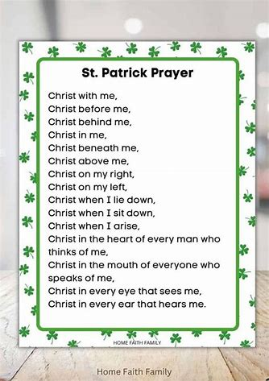 | 17No School   | 18  No School | 19  No School | 20   | 21  No School | 22
23 | 24  Meatball Sub  Broccoli w/dip  Corn  Applesauce | 25  Beef Chili w/corn chips  Celery Sticks /dip  Fresh Orange  Chocolate Chip Cookie | 26  Turkey ala King  Rice  Garlic Toast  Mixed Vegetables  Pineapple Tidbits | 27  Popcorn Chicken  Mashed Potatoes w/country gravy  Cucumber Slices  Tropical Fruit | 28  Macaroni and Cheese  Peas  Broccoli w/dip  Fresh Apple | 29
30 | 31  Maid Rite  Sweet Potato Fries  Baked Beans  Fresh Orange |  |  |  |  | 
 | God Bless Our Families! |  |  | Menus are subject to change. | All meals are served with a  ½ pint of Skim Chocolate, or 1% White milk

